Anger Ladder Reflection
Anger can take many forms. Learning to pay better attention to your anger (and all feelings) will give you an opportunity to address them. Describe your own anger ladder and fill out the chart describing how you feel anger, what actions follow, and the impact.
10- angriest you’ve ever been

9

8

7

6

5

4

3

2

1

0 Totally
Calm
My Body Feels | My Action | The Impact
Eg: Tunnel vision | Eg: Hurt people | Eg: Cause pain, break trust.
Eg: Tight chest | Eg: Yell | Eg: Create fear
Eg: Get warmer | Eg: Make a fist
 | Eg: can’t sit still
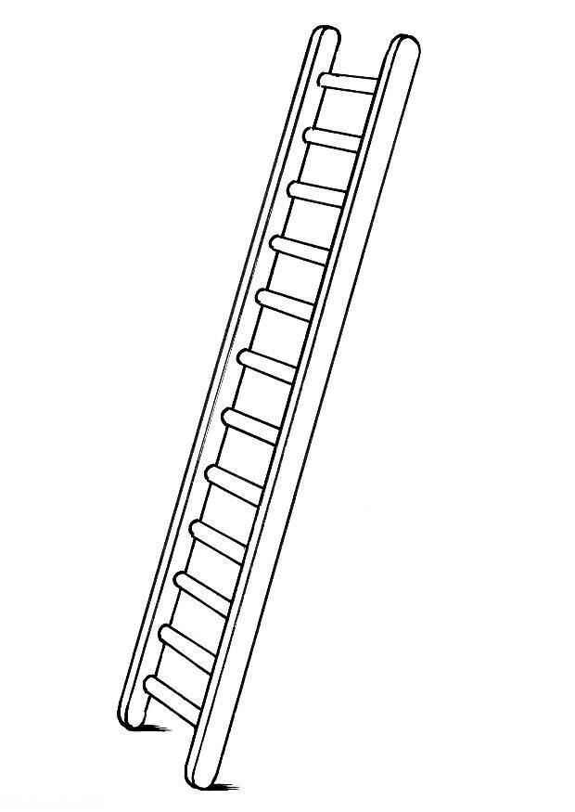

2. What things regularly trigger your anger?

3. What helps you to stop the progression of your anger?

4. What helps you to climb down the ladder and calm down when you’re angry?

5. Where did you learn how to deal with your anger?

6. What would you change about your anger if you could?

7. What would your partner and/or children want you to change about how you express your anger?

8. What can you do to reach these goals?

